UR PERCENTILE
Visit : http://groups.yahoo.com/group/urpercentile/
Preparing for entrance exam for top Management Institute ?
Join Us.

LESSON P1074 Time Limit : 20 Minutes
http://groups.yahoo.com/group/urpercentile/

Q1 to Q5 are based on the following graph which shows the sales of different soft-drinks in various regions of a state:

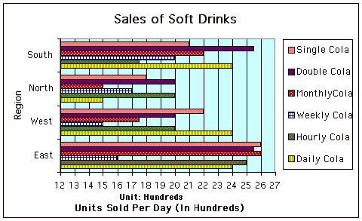

Q1. How many units of Double Cola are sold in the state per day?
Choices : 8700, 8900, 8500, 8600
Q2. What % of Single Cola's sales come from North region ?
Choices : 20.68 %, 23.68%, 19.01%, 23.01%
Q3. What is total consumption of units per day of the South Region ?
Choices : 13,000, 12,500, 13,500, 14,000
Q4. Which Cola has the maximum sales in terms of Revenue earned in the state?
Choices : Double Cola, Single Cola, Weekly Cola, Daily Cola, Cannot be determined.
Q5. Which region has the least consumption per day (Assume each unit of all Cola to be of same quantity) ? Choices : North, South , East , West

http://groups.yahoo.com/group/urpercentile/

Q6 to Q10 are based on the following graph which is based on sales of different soft-drinks in various regions of a state:

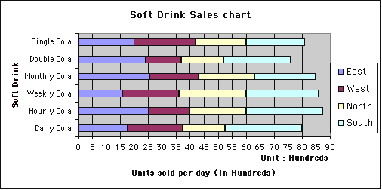

Q6. What is the total number of units sold per day in the state ?
Choices : 51,550, 52,550, 49,550, 47,550
Q7. Which drink is sold the least in West region ?
Choices : Double Cola, Monthly Cola, Daily Cola, Cannot be determined.
Q8. What is the total number of units sold in West ?
Choices : 10,750, 11,750, 12,250, Cannot be determined.
Q9. How many more units of Double Cola should be sold so that it sales become equal to Hourly Cola at state level? Choices : 1,150, 1,250, 11.50, Cannot be determined.
Q10. What % of Single Cola's sale comes from the South region ?
Choices : 25.02 %, 25.92 %, 26.82%, Cannot be determined.

http://groups.yahoo.com/group/urpercentile/

Q11 to Q16 are based on the following two graphs which are based on sales of different soft-drinks in various regions of a state. The Pie-chart represent the market share of each soft drink in terms of the sales revenue while the second graph represent the number of bottles sold in various region of the state.

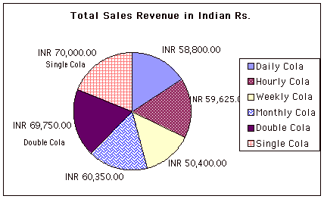

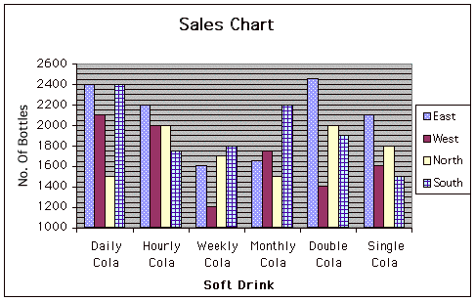

Q11. What is the cost of one bottle of Single Cola ? Choices : 9,10,9.5,10.5
Q12. What is the total collection of Weekly Cola from South region ?
Choices : 14,400, 15,500, 16,600, Cannot be determined.
Q13. Which Cola is the most expensive one ?
Q14. Which region consume the most number of bottles of soft drink ?
Q15. Which soft drink sell the maximum is terms of number of bottles ?
Q16. What is the sales collection of “Monthly Cola” from North Region ?

http://groups.yahoo.com/group/urpercentile/

Q17 to Q21 are based on the following graph which represent the sales of different soft-drinks in various regions of a state:

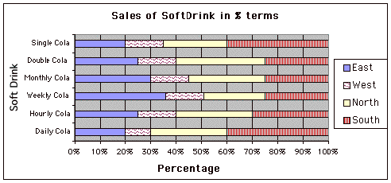

Q17. Which region of the state consume the most of the soft drink ?
Choices : North , South , East, Cannot be determined.
Q18. Which region of the state consume the least amount of soft-drink ?
Choices : East , West, South , Cannot be determined.
Q19. If the total consumption of east region is 11,300 bottles, How many Single Cola does the region consume ? Choices : 1000, 2000, 1500, Cannot be determined.
Q20. If a total of 2,100 bottles of Daily cola are sold in East and West region combined, how many total bottles of Daily Cola are sold in North and South region combined ?
Choices : 4,900, 4,400, 4,800, Cannot be determined.
Q21. Assume the total consumption of the state to be 42,500 bottles per day and that sales of Hourly cola to be 2,400 bottles per day in North region. What is the market share of Hourly Cola in the state in terms of bottle sold? (All bottles are of same size)

MATCH THE WORDS IN SET A WITH THEIR MEANINGS IN SET B

SET A :
Q22. Mendacious Q23. Doyen Q24. Sanguine Q25. Quintessence Q26. Uxorious

SET B:
A. Excessive
B. Habitually hopeful ,confident .
C. Foolishly fond of or submissive toward one’s wife
D. Dean
E. Most essential part of any substance, refined extract .
F. Lying , untruthful .
G. The other team in a contest
H. A thing with odd smell.
I. In a very happy mood.

http://groups.yahoo.com/group/urpercentile/

